Caterpillar Salesforce CPQ Implementation 1.0: Technical Design Document

# **PDF Quote Generation**

## Overview

This document will provide technical explanation about the CPQ - PDF Quote Generation functionality including all the components used, configuration, code, integration and data customization to implement the solution.

PDF Quote is required for the customer who needs electronic record of Quote data for the Products.

## Object and Field definition

Below is the list of components used to make PDF Quote Functionality working.

|  |  |  |  |
| --- | --- | --- | --- |
| **Component Type** | **Object Name** | **Component Label** | **Component API Name** |
| Custom Object | Mining Escalator Data | Mining Escalator Data | Mining_Escalator_Data__c |
| Custom Field |  | Date | Date__c |
| Custom Field |  | [Escalation](https://catcrm--hclcrmi.cs25.my.salesforce.com/00N1b000000az9k?setupid=CustomObjects) | Rate__c |
| Custom Field |  | [Model](https://catcrm--hclcrmi.cs25.my.salesforce.com/00N1b000000az9i?setupid=CustomObjects) | Model__c |
| Custom Field |  | [Price Book](https://catcrm--hclcrmi.cs25.my.salesforce.com/00N1b000000az9j?setupid=CustomObjects) | Price_Book__c |
| Custom Field |  | [Region](https://catcrm--hclcrmi.cs25.my.salesforce.com/00N1b000000az9l?setupid=CustomObjects) | Region__c |
| Tab |  | Mining Escalator Data | Mining_Escalator_Data__c |
| Page Layout |  | Mining Escalator Data Layout | Mining Escalator Data Layout |
| Custom Object | Opportunity Quote Tracking | Opportunity Quote Tracking | Opportunity_Quote_Tracking__c |
| Custom Field |  | [Opportunity](https://catcrm--hclcrmi.cs25.my.salesforce.com/00N1b000000azAa?setupid=CustomObjects) | Opportunity__c |
| Custom Field |  | [Quote Comments](https://catcrm--hclcrmi.cs25.my.salesforce.com/00N1b000000azAe?setupid=CustomObjects) | Quote_Comments__c |
| Custom Field |  | [Quote Create Date](https://catcrm--hclcrmi.cs25.my.salesforce.com/00N1b000000azAf?setupid=CustomObjects) | Quote_Create_Date__c |
| Custom Field |  | [Quote Number](https://catcrm--hclcrmi.cs25.my.salesforce.com/00N1b000000azAc?setupid=CustomObjects) | QuoteNumber__c |
| Custom Field |  | [Quote Valid Until:](https://catcrm--hclcrmi.cs25.my.salesforce.com/00N1b000000azAb?setupid=CustomObjects) | QuoteEndDate__c |
| Custom Field |  | [Quote Version](https://catcrm--hclcrmi.cs25.my.salesforce.com/00N1b000000azAd?setupid=CustomObjects) | QuoteVersion__c |
| Page Layout |  | Opportunity Quote Tracking Layout | Opportunity Quote Tracking Layout |
| Standard Object | Opportunity | Opportunity | Opportunity |
| Custom Field |  | Quote Version | QuoteVersion__c |
| Custom Field |  | Type of Sale | Type_Of_Sale__c |
| Custom Field |  | Worksite Name | Worksite_Name__c |
| Custom Field |  | Status | Status__c |
| Custom Field |  | Quote Number | QuoteNumber__c |
| Custom Field |  | Total Sales Price | CGM_Total_Sales_Price__c |
| Custom Field |  | ID | Record_Number__c |
| Page Layout |  | Mining Layout | Mining Layout |
| Standard Object | Opportunity Product | Opportunity Product | OpportunityLineItem |
| Custom Field |  | Product Name | Product_Name__c |
| Custom Field |  | Planned RTS Date | Planned_RTS_Date__c |
| Custom Field |  | CGM Total Value | CGM_Total_Value__c |
| Custom Field |  | Show On Quote | Show_on_Quote__c |
| Custom Field |  | Status | Status__c |
| Custom Field |  | Quote Comments | Quote_Comments__c |
| Custom Field |  | Escalator Per Unit | CGM_Escalator_Per_Unit__c |
| Custom Field |  | Price Per Unit | CGM_Dealer_Price_Per_Unit__c |
| Custom Field |  | Product Group | CGM_Product_Group__c |
| Custom Field |  | Per Unit $ Discount | CGM_Per_Unit_Doll_Disc__c |
| Custom Field |  | Net Price Per Unit | CGM_Net_Price_Unit__c |
| Standard Object | Account | Account | Account |
| Custom Field |  | Global Account | Global_Account__c |

## Apex classes and Visualforce Pages

|  |  |  |
| --- | --- | --- |
| **Apex Controller Class** | **Visualforce Page** | **Test Class** |
| PDFQuotePriceBookCheck | PDFQuotePriceBookCheck | PDFQuotePriceBookcheckTest |
| PDFGenratController | Quote | PDFGenrat_Test |
|  | QuoteGenerationError |  |

## Page Payouts

Opportunity Mining Layout is customized for the PDF Quote Generation Functionality as captured below:

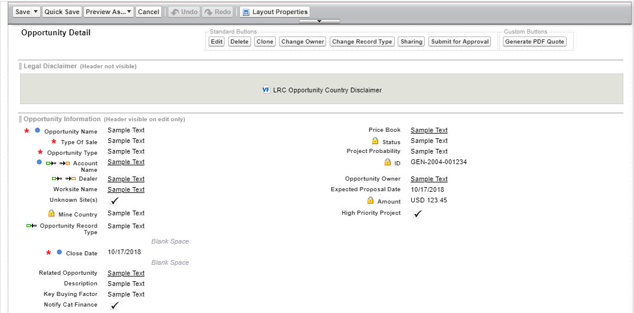

## Customizations

Since JavaScript button is not supported by Salesforce Lightening, Action button called “Generate PDF Quote” is created.

Action Button will be displayed on the Opportunity Layout to generate PDF Quote for the Products customer is interested in.

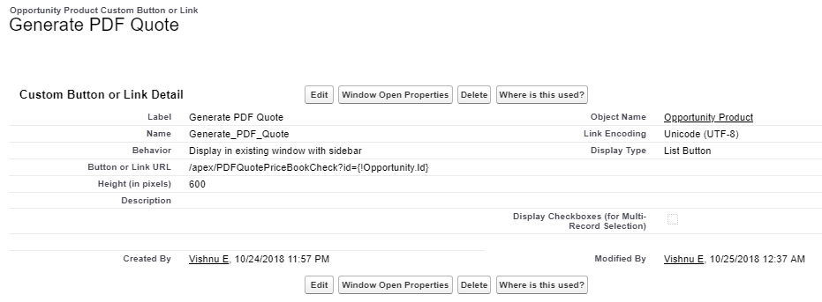

“Generate PDF Quote” Action will be displayed on the Opportunity Page Layout as captured below:

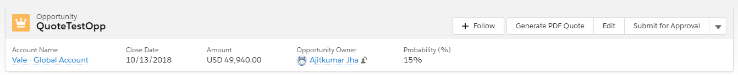

## Other Considerations and Assumption

* Opportunity is created with correct data.
* Opportunity is attached to a custom pricebook.
* Products is added to the opportunity with valid fields.
* Show on Quote, on the Product is either Can Quote, Must Quote to show up on the PDF Quote.
* “Show on Quote” checkbox is checked on the line Items to show on the Quote.
* Opportunity is related to at least one account.
* Status of the Product is Open.

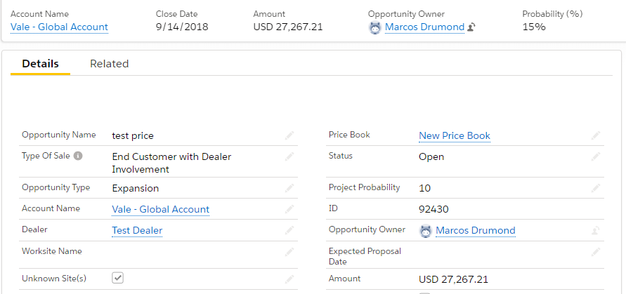

### Pricebook Refresh:

Pricebook is a Standard object and attached to an opportunity along with Products.

If PDF Quote is older than 60 days and Pricebook is inactive attached to the Opportunity, then pricebook refresh is required before generating PDF Quote.

Show on Quote**:** On a Products which are added in the Opportunity will have 3 actions in it to select.

* **Can Quote:** It’s an optional, i.e. Show on Quote option will be available on VF page will not be checked by default and user can check or uncheck that. Means user decides that product will be shown on the PDF Quote or not.
* **Can’t Quote:** In this case, Show on Quote check box will be blank and Read Only on the VF page. By default, that product will not be shown on PDF Quote.
* **Must Quote:** In case of must quote option, Show on Quote checkbox will be Read Only, but checkbox will be on. i.e. Product must be shown on the PDF Quote.

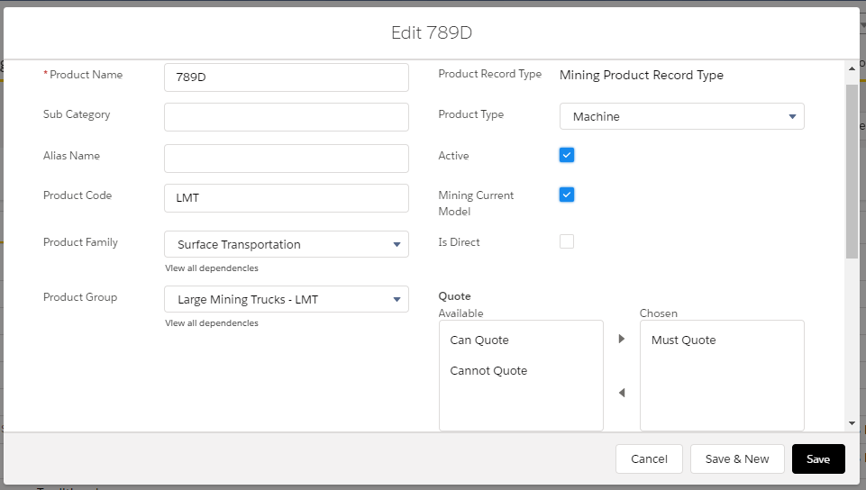

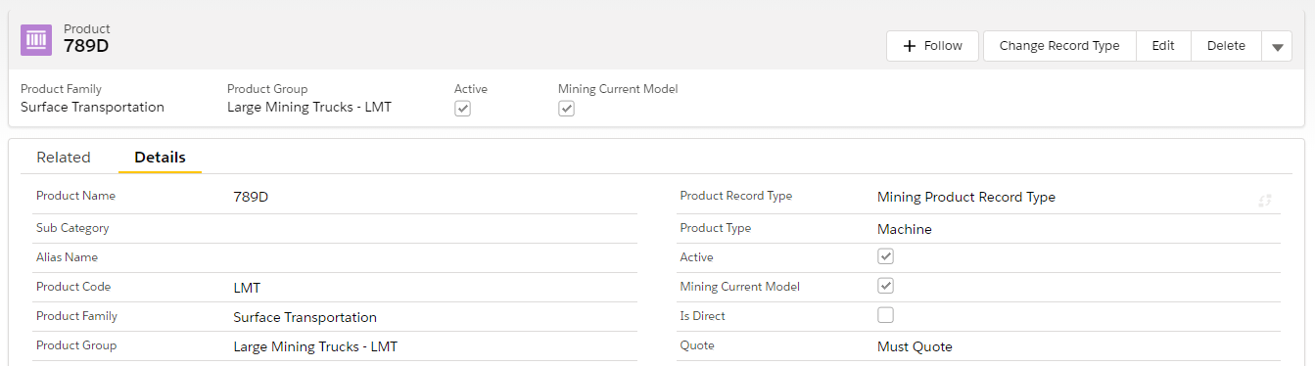

## **Escalated Product:**

There can be some escalated products added to an Opportunity. All the escalated products will be shown up in a different table called Escalation Details which contains Escalated Product name, escalation date and rate.

Condition:

If Planned RTS Date of the Product is longer than the date of the product which are added at the time of the Opportunity Product addition to the Opportunity, then product is called escalated product.

1. Model (Product Name)
2. Escalation Date (Escalation effective date for the year specified in Planned RTS date from Escalation Data Object)
3. Escalation Rate (Escalation Percentage for the Model from Escalation Data Object)

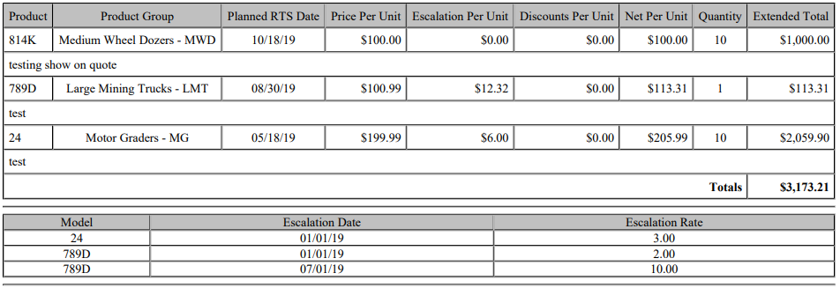

## **Notes and Attachments:**

All the created PDF Quotes for the Opportunities are saved to Notes and Attachments section.

All PDFs will be saved with Opportunity ID, Quote Number and Quote Version for future use.

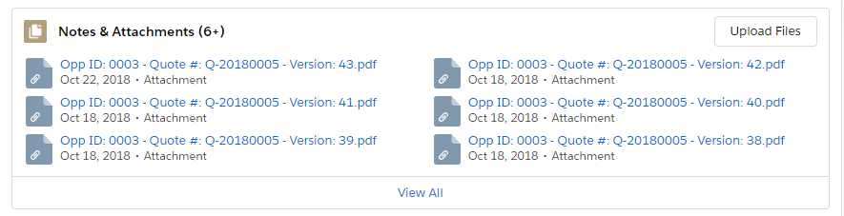

# **Opportunity Product Add Line Item and Details Page**

## Overview

Idea is to have an ability to add a list of products to an Opportunity so that users can list products that a customer is interesting in purchasing.

Only Users with profiles CGM Standard User, CGM Super User and System Administrator can **add and edit a line item** to an Opportunity.

As a global mining user with profiles CGM Standard User, CGM Super User and System Administrator can view or enter details for the specific Product’s Model selected so that user can specify or view quantity and other details pertaining to the model in the line item.

## Object and Field definition

## Apex classes and Visualforce Pages:

Here are the Apex classes and Visualforce pages used for the Add line item functionality:

|  |  |  |
| --- | --- | --- |
| **Apex Controller Class** | **Visualforce Page** | **Test Class** |
| Configurator_Lite_Controller |  |  |
| ConfiguratorLiteProduct |  |  |
| Configurator_Lite_OppLineItem | Configurator_Lite_OppLineItem |  |
| CGMPricebookRefresh |  | CGMPriceBookRefreshTest |
| OLIEditRedirect | OLIEditRedirect | OLIEditRedirectTest |
| Configurator_Lite | [Configurator_Lite](https://catcrm--datamig.cs52.my.salesforce.com/0665B000000IpYuQAK) | Configurator_Lite_Test |
|  |  |  |

## Page Payouts

A custom “Add Line Item” Button is created to add products for the Opportunity.

#### Custom “Add Line Item” Button:

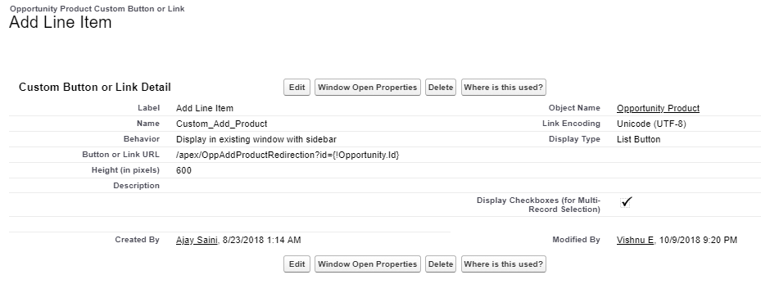

## Customizations

### Add Line Item:

To add the products to the Opportunity a button “Add Line Item” is created so that users with profiles CGM Standard User, CGM Super User and System Administrator can **add a line item** to an Opportunity.

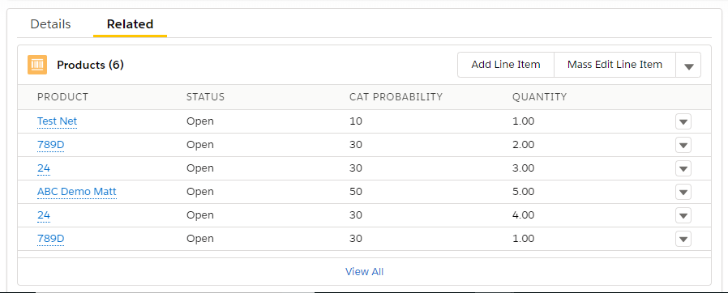

### Edit Line Item:

In case any modifications required User can edit line item by selecting Product:

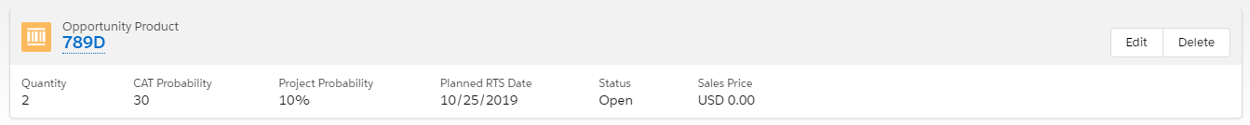

Editing Escalator per unit field:

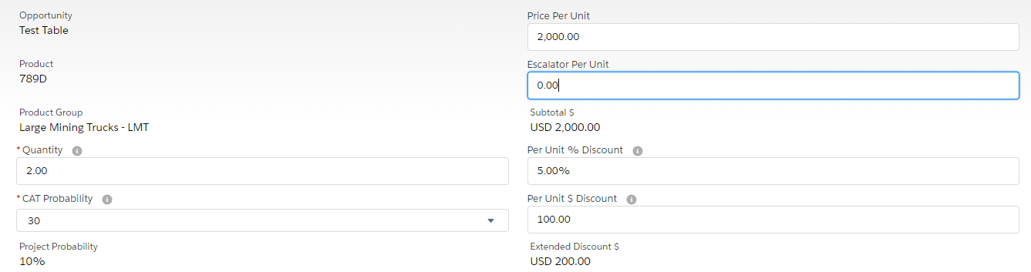

## Other Considerations and Assumption

* An Opportunity is in Open Status to add a line Item to the Opportunity.
* Opportunity record should exist in the system where Opportunity record type = Mining (If not create a new Opportunity.)
* Field **Type of Sale = Direct Sale to Customer (No Dealer Involvement)** in the Opportunity
* Users profile is CGM Standard User, CGM Super User or System Administrator only.

### Model Unknown:

Model Unknown checkbox is used to show whether Model for the Product Group is available or not.

If Model is available for the Product Group, Model Unknown checkbox will get hide automatically and if Model is not available for the Product Group, Model Unknown checkbox will get checked automatically as shown below:

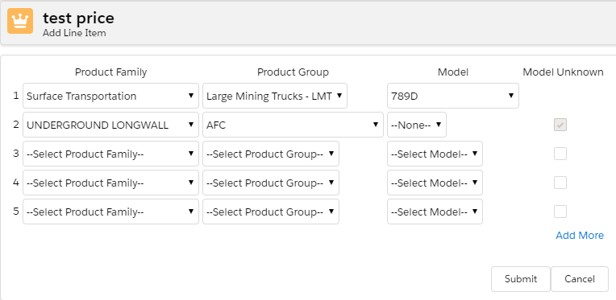

### Add More Button:

Add more button is used when more products need to be added. Every time we “Add More” Button is clicked, 5 additional line items will get available to add the products for the Opportunity.

# **Close Details**

## Overview

A Custom Page will be embedded into line Item Detail Page to capture all the required Closing details which will function independently of the Line Item Details.

Whenever Status field is changed to Won/Lost/Cancelled. A warning massage should appear for the Product.

## Object and Field definition

|  |  |  |  |
| --- | --- | --- | --- |
| **Component Type** | **Object Name** | **Component Label** | **Component API Name** |
| Custom Object | Opportunity Quote Tracking | Opportunity Quote Tracking | Opportunity_Quote_Tracking__c |
| Custom Field |  | [Opportunity](https://catcrm--hclcrmi.cs25.my.salesforce.com/00N1b000000azAa?setupid=CustomObjects) | **Opportunity__c** |
| Custom Field |  | [Quote Create Date](https://catcrm--hclcrmi.cs25.my.salesforce.com/00N1b000000azAf?setupid=CustomObjects) | **Quote_Create_Date__c** |
| Custom Field |  | [Quote Valid Until:](https://catcrm--hclcrmi.cs25.my.salesforce.com/00N1b000000azAb?setupid=CustomObjects) | **QuoteEndDate__c** |
| Custom Field |  | [Quote Version](https://catcrm--hclcrmi.cs25.my.salesforce.com/00N1b000000azAd?setupid=CustomObjects) | **QuoteVersion__c** |
| Page Layout |  | Opportunity Quote Tracking Layout | Opportunity Quote Tracking Layout |
| Standard Object | Opportunity | Opportunity | Opportunity |
| Custom Field |  | Quote Version | QuoteVersion__c |
| Custom Field |  | Type of Sale | Type_Of_Sale__c |
| Custom Field |  | Worksite Name | Worksite_Name__c |
| Custom Field |  | Status | Status__c |
| Custom Field |  | Quote Number | QuoteNumber__c |
| Custom Field |  | Project Probability | Project_Probability__c |
| Page Layout |  | Mining Layout | Mining Layout |
| Standard Object | Product | Product | Product2 |
| Custom Field |  | Product Type | Product_Type__c |
| Custom Field |  | Mining Current Model | Mining_Current_Model__c |
| Custom Field |  | Product Group | CGM_Product_Group__c |
| Custom Field |  | Quote | Quote__c |

## Apex classes and Visualforce Pages

|  |  |  |
| --- | --- | --- |
| **Apex Controller Class** | **Visualforce Page** | **Test Class** |
| Configurator_Lite_Controller | Configurator_Lite_OppLineItem | PDFQuotePriceBookcheckTest |

## Other Considerations and Assumption

* User should have access to below profiles:  
  a. CGM Standard User   
  b. CGM Super User
* Opportunity record should exist in the system where Status = Open (If not create a new Opportunity.)
* All fields are editable in Line Item Detail Section except for Read-only fields if status = Open.
* User cannot save any changes to the fields when Status field is changed to 'Won'
* User cannot save any changes to the fields when Status field is changed to 'Lost'
* User cannot save any changes to the fields when Status field is changed to 'Cancelled'
* If Status = Open then, no other fields are required to be visible for Close Detail Section.

# **Configurator Attributes**

## Overview

User with profiles of CGM Super User, CGM Standard User and System Administrator should have ability to fill in Configurator details so that users can choose configurator attributes of a Longwall Product.

Configurator Attributes section show up the only Longwall Products and its related details.

## Object and Field definition

## Apex classes and Visualforce Pages

## Page Payouts

## Customizations

## Other Considerations and Assumption

If product family is Underground Logwall then below will be Product Groups: AFC, Auxiliary Equipment and Services, BSL, Electro Hydraulic Controls, Plow, Roof Support, Shearer

Only Users with below profiles to fill in Configurator details of a Longwall Product.

* CGM Standard User
* CGM Super User
* System Admin

Opportunity record should exists in the system where Project probability >= 60%.